Name: A.Reddy Sulochana
Reg.No: 192372370

Exp.No.07 Breadth-First Search (BFS)
01.08.26

Aim:
To implement the Breadth-First Search (BFS) algorithm in Python and traverse all the vertices of a graph from a given starting node.
Algorithm:
- Start the program.
- Read the number of vertices.
- Read each vertex and its adjacent vertices.
- Read the starting vertex.
- Create an empty queue and visited list.
- Insert the starting vertex into the queue and mark it as visited.
- Remove a vertex from the front of the queue and display it.
- Add all unvisited adjacent vertices to the queue.
- Repeat Steps 7–8 until the queue is empty.
- Stop the program.
Program:
from collections import deque
graph = {}
n = int(input("Enter number of vertices: "))
for i in range(n):
vertex = input("Enter vertex: ")
neighbours = input("Enter adjacent vertices (space-separated): ").split()
graph[vertex] = neighbours
start = input("Enter starting vertex: ")
visited = []
queue = deque()
visited.append(start)
queue.append(start)
print("BFS Traversal:")
while queue:
node = queue.popleft()
print(node, end=" ")
for neighbour in graph[node]:
if neighbour not in visited:
visited.append(neighbour)
queue.append(neighbour)

Input:
Enter number of vertices: 6
Enter vertex: A
Enter adjacent vertices (space-separated): B C
Enter vertex: B
Enter adjacent vertices (space-separated): D E
Enter vertex: C
Enter adjacent vertices (space-separated): F
Enter vertex: D
Enter adjacent vertices (space-separated):
Enter vertex: E
Enter adjacent vertices (space-separated): F
Enter vertex: F
Enter adjacent vertices (space-separated):
Enter starting vertex: A
Output:
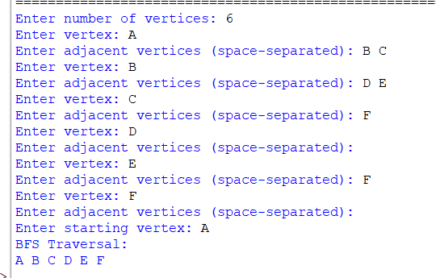

Result:
Thus, the Python program to implement the Breadth-First Search (BFS) algorithm was executed successfully, and the graph was traversed in BFS order starting from the given source vertex.

